**WIRELESS ADVANCED FLIGHT SYSTEMS AIRCRAFT MONITORING SYSTEM**

**ABSTRACT**

An update from the original ACS2002, the AF-2500 is a complete aircraft monitoring and data acquisition system designed for aircraft with 4 or 6 cylinder engines. More than simply an engine monitor, the AF-2500 provides aircraft monitoring functions, a complete fuel computer system, and completely customizable electronic checklists.

Every engine instrument reading is continuously gathered, compared against user-configurable set points, and displayed on a sunlight readable, color Display. Unlike other systems, the display can be customized to the user's preference. Any of the standard instruments can be eliminated or added to the screen. The screen can be oriented horizontally or vertically.

In this project we are monitoring the aircrafts condition through sensors like temperature , humidity and pressure sensor and sends this information from the transmitter section to receiver section through wirelessly using RF Communication.

**BLOCK DIAGRAM**

**TRANSMITTER SECTION:**

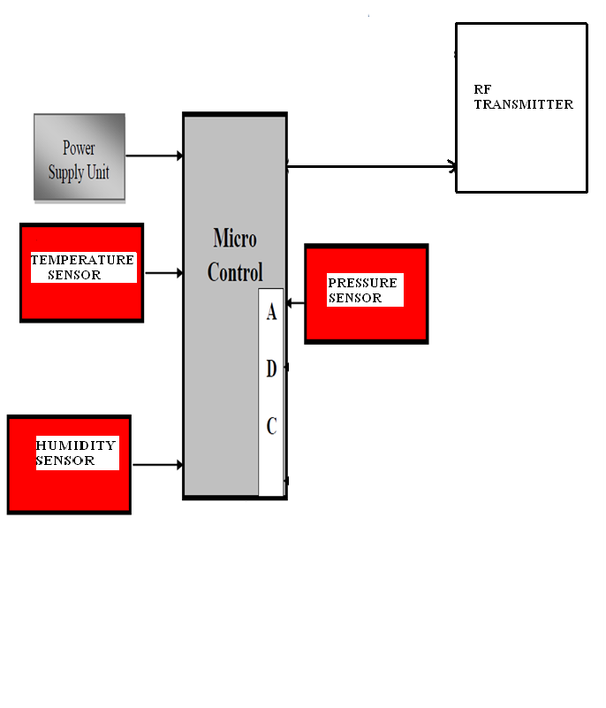

**RECEIVER SECTION:**

